What is an IaaS?

Demonstrate IaaS using GCP/AWS.

Which FOSS installation you used for completing the experiment?

1. GO TO EC2 AND LAUNCH INSTANCE
2. NAME AND SELECT UBUNTU
3. PROCEED WITHOUT KEY PAIR
4. CONNECT TO INSTANCE
5. UBUNTU MESSAGE IS CREATED

What is an IaaS?

Demonstrate IaaS using FOSS.

Which FOSS installation you used for completing the experiment?

What is a PaaS?

Demonstrate PaaS using FOSS.

Which FOSS installation you used for completing the experiment?

What is a SaaS?

Demonstrate SaaS using FOSS.

Which FOSS installation you used for completing the experiment?

. 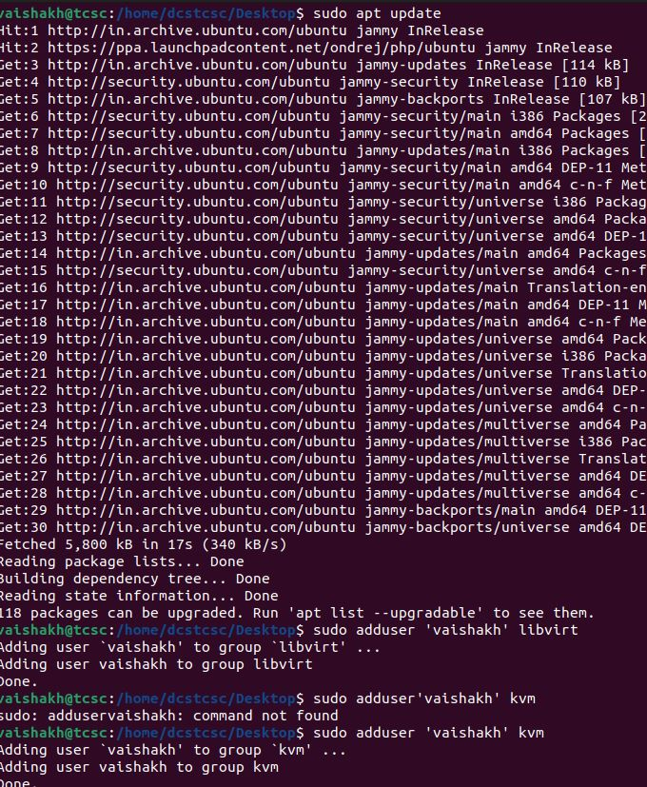

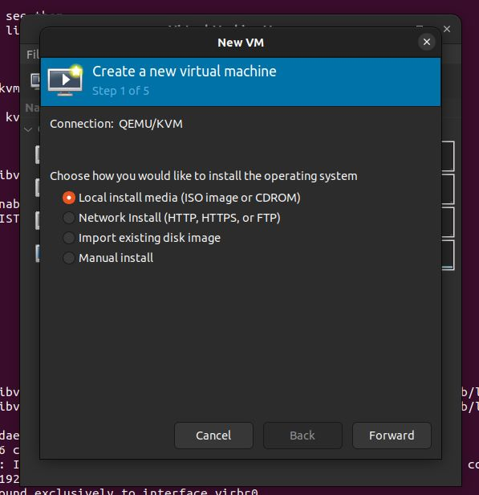

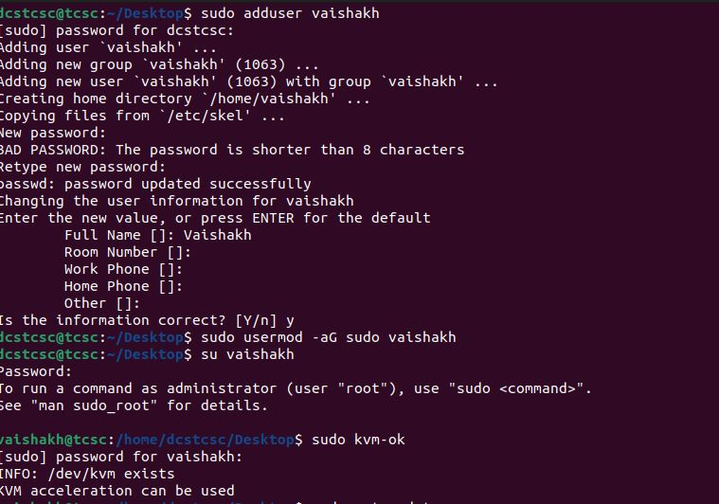

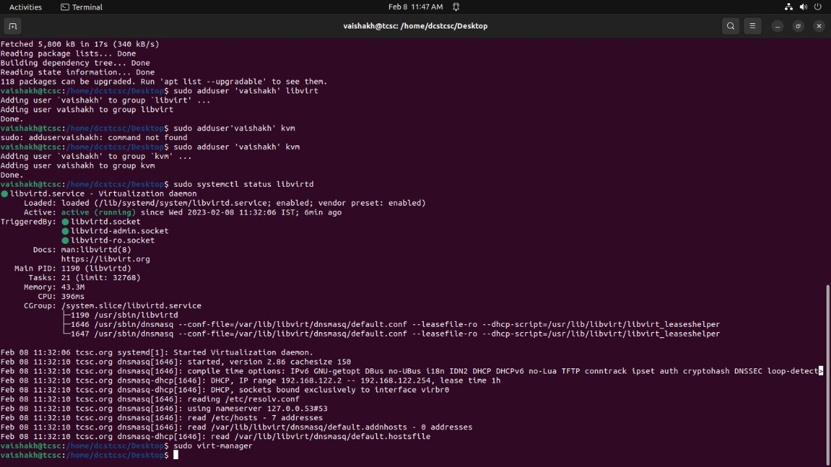

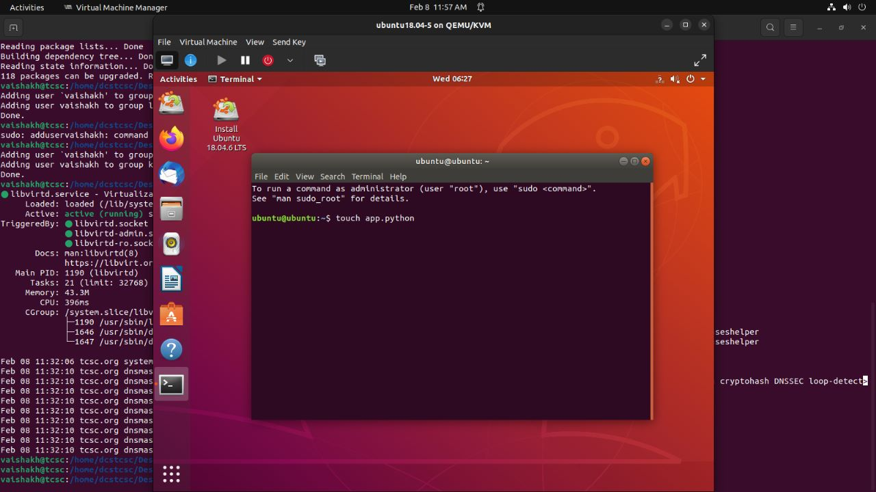

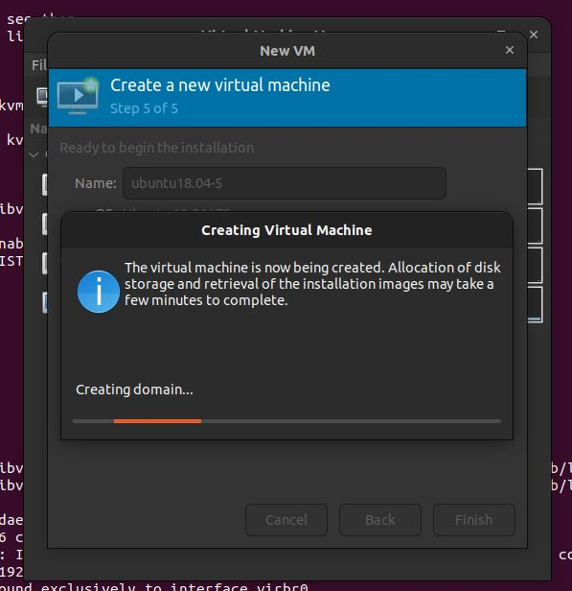

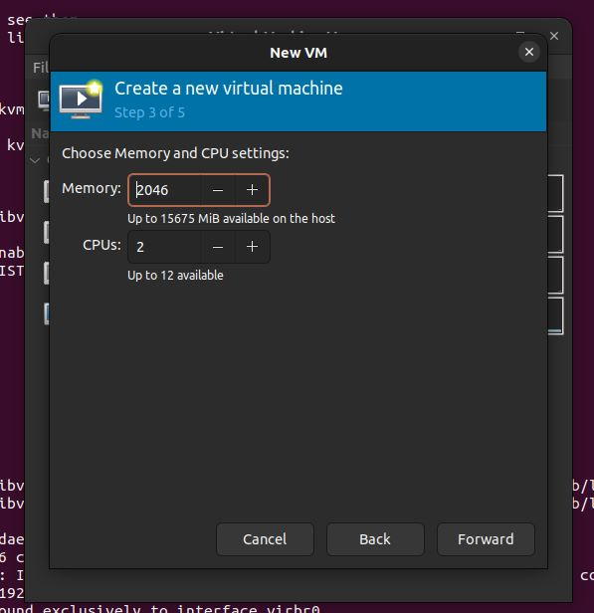



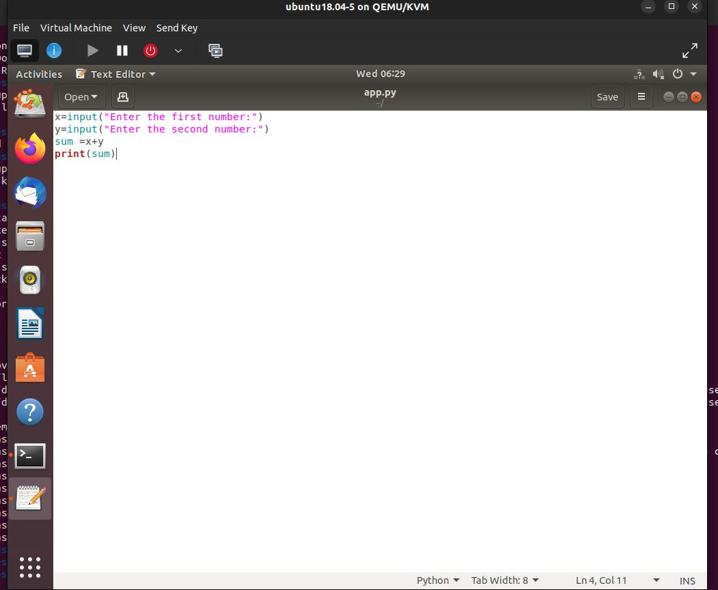

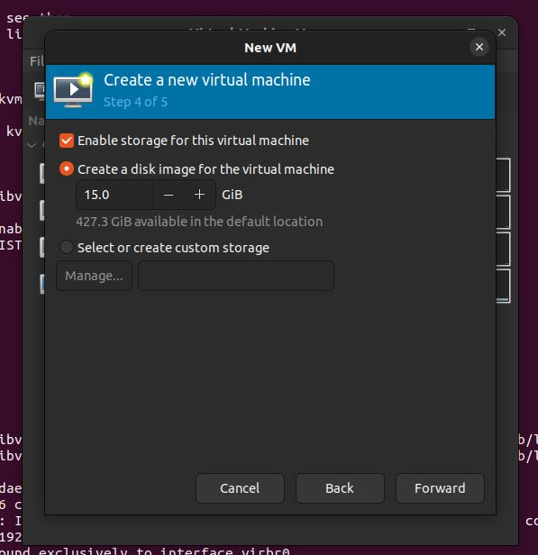

What is a PaaS?

Demonstrate PaaS using GCP/AWS.

Which FOSS installation you used for completing the experiment?

1. GO TO ELASTIC BEANSTALK and CREATE ENVIRNONMENT
2. SELECT THE LINK
3. URL PAGE WILL BE FORMED

What is a SaaS?

Demonstrate SaaS using GCP/AWS.

Which FOSS installation you used for completing the experiment?

1. GO TO AMAZON WORK DOCS , CORRECT MAIL
2. ENTER MAIL IN NEW WINDOW AND RESET PASSWORD

What is an IAM? What are its benefits?

Demonstrate IAM using GCP/AWS.

1. GO IAM , ADD USER, click provide user box
2. Add password click next add to user , create user
3. Return to lists , copy link in incognito,
4. Sign in as IAM user, add new password

What is a Multi-factor Authentication (MFA)? Why is it important?

How Multi-factor authentication might be implemented in different ways?

Demonstrate MFA use in GCP/AWS.

1. Go to mfa device,authentication
2. SAME AS IAM FOLLOW STEPS AFTER INCOGNITO.

What is SSO? Why is SSO important?

How does SSO compare with other access management solutions in AWS?

Demonstrate use of SSO in AWS.

1. GO TO IAM SSO, CREATE USER, SELECT GROUP,ADD USER
2. Go permission sets,give any permission,
3. Assign users in aws account
4. Go to email